**SQL Joins assignment**

**Database Schema**

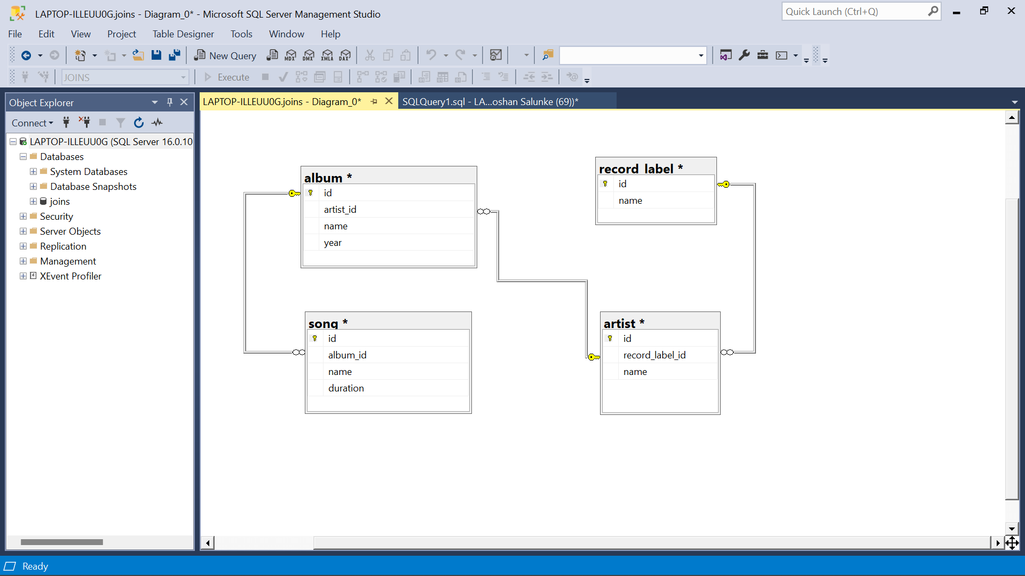

Initial queries for database, table creation and inserting values

Create and use database

create database joins;

use joins;

Create Tables

CREATE table album (id int, artist_id int, name varchar(100), year int)

CREATE table song (id int, album_id int, name varchar(50), duration float(20))

CREATE table record_label (id int, name varchar(50))

CREATE table artist (id int, record_label_id int, name varchar(50))

Inserting Values

INSERT INTO album (id, artist_id, name, year) VALUES(1, 1, 'Devils got a new disguise', 2006),

(2,1,'Keeps getting better',2008),

(3, 1,'Master of Puppets',1986),

(4, 2,'Endgame',2009),

(5, 2,'Icon',2012),

(6,3,'Story',2000),

(7,4,'Chapters',2003),

(8,4,'Riding with the King',2000),

(9,5,'Pieces of a Dream',2005),

(10,6,'Greatest Hits',2004),

(11,7,'All-Time Greatest Hits',1975),

(12,8,'Greatest Hits',1983),(13,9,'Ultimate Collection',2015)

INSERT INTO song (id, album_id, name, duration) VALUES(1,1,'Dream On',4.26),(2,1,'Back in the Saddle',4.40),

(3,2,'Genie in a Bottle',5.3),

(4,2,'Beautiful',5.29),

(5,3,'Master of Puppets',8.35),

(6,3,'Battery',5.13),

(7,4,'Dialectic Chaos',2.26),

(8,4,'Endgame',5.57),

(9,5,'Watching Airplanes',4.03),

(10,5,'Man to Man',3.41),

(11,6,'Balck Winter Day',3.48),

(12,6,'Against Widows',4.04),

(13,7,'Reptile',3.36),

(14,7,'Modern Girl',4.49),

(15,8,'Riding with the King',4.23),

(16,8,'Key to the Highway',3.39),

(17,9,'Im Outta Love',4.02),

(18,9,'Not That Kind',3.20),

(19,10,'Eruption',1.43),

(20,10,'Hot For Teacher',4.43),

(21,11,'Sweet Home Alabama',4.45),

(22,11,'Free Bird',14.23),

(23,12,'Thunderstruck',4.52),

(24,12,'T.N.T',3.35),

(25,13,'Sgt. Pepper''s Lonely Hearts Club Band',2.0333),

(26,13,'With a Little Help from My Friends',2.7333),

(27,13,'Lucy in the Sky with Diamonds',3.4666),

(28,13,'Getting Better',2.8),(29,13,'Fixing a Hole',2.6),

(30,13,'Shes Leaving Home',3.5833),

(31,13,'Being for the Benefit of Mr. Kite!',2.6166),

(32,13,'Within You Without You',5.066),

(33,13,'When I''m Sixty-Four',2.6166),

(34,13,'Lovely Rita',2.7),

(35,13,'Good Morning Good Morning',2.6833),

(36,13,'Sgt. Pepper''s Lonely Hearts Club Band (Reprise)',1.3166),

(37,13,'A Day in the Life',5.65)

INSERT INTO record_label (id, name) VALUES(1,'Blackened'),

(6,'Capitol'),

(5,'Elektra'),

(4,'MCA'),

(3,'Universal'),

(2,'Warner Bros')

INSERT INTO artist (id, record_label_id, name) VALUES(3,1,'Anthrax'),

(2,1,'Christina'),

(1,1,'Aerosmith'),

(4,2,'Eric Clapton'),

(6,2,'Amorphis'),

(5,2,'Gary Allan'),

(8,3,'AC/DC'),

(7,3,'Lynyrd Skynyrd'),

(9,6,'Anastacia')

Assignment Questions

Q1. Show all the 4 tables(album, song, record label and artist)

Output:-

select * from album;

select * from song;

select * from record_label ;

select * from artist;

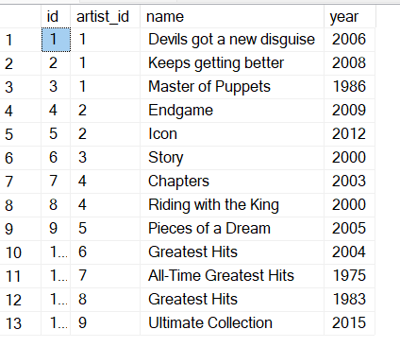

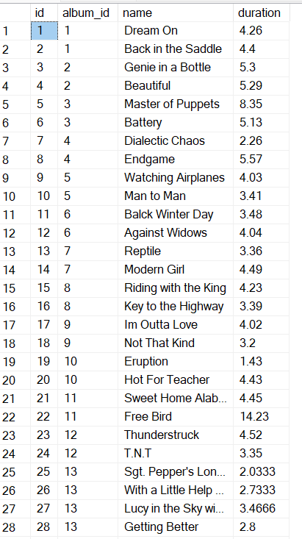

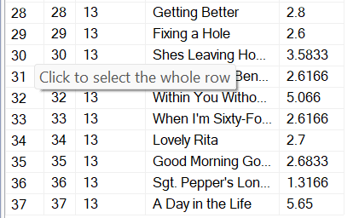

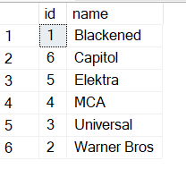

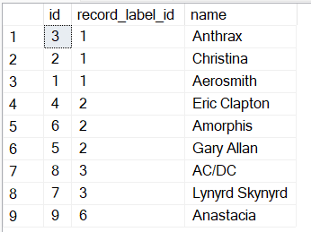

2 List all artists for each record label sorted by artist name.

select ar.name 'artist name',r.name'record label name' from record_label r

join

artist ar on r.id=ar.record_label_id

order by ar.name;

Output:

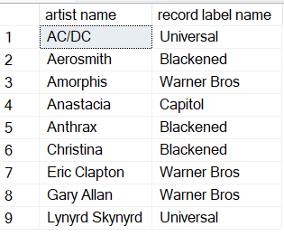

3.Which record labels have no artists?

SELECT r.name 'record name' from record_label r

left join artist ar

ON r.id=ar.record_label_id

where ar.record_label_id is null;

Output:

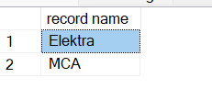

4. List the number of songs per artist in descending order

select ar.name 'artist name', count(*)'no. of songs'

from song s

join album al

on s.album_id=al.id

join artist ar on al.artist_id=ar.id

Group by ar.name

order by count(*) desc;

Output:

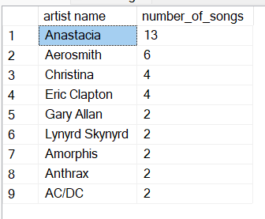

5. Which artist or artists have recorded the most number of songs?

select top 1 ar.name 'artist name', count(*)'no. of songs'

from song s

join album al

on s.album_id=al.id

join artist ar on al.artist_id=ar.id

Group by ar.name

order by count(*) desc;

Note: In Microsoft Server Studio use top n instead of limit

Output:

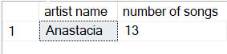

6.Which artist or artists have recorded the least number of songs?

select top 5 ar.name 'artist name', count(*)'no. of songs'

from song s

join album al

on s.album_id=al.id

join artist ar on al.artist_id=ar.id

Group by ar.name

order by count(*) asc;

Output:

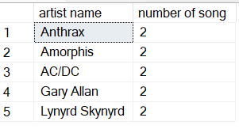

7.which artists have recorded songs longer than 5 minutes, and how many songs was that?

select ar.name 'artist name',count(*) 'no, of songs'

from song s

join album al

on s.album_id=al.id

join artist ar on al.artist_id=ar.id

where s.duration>5

group by ar.name;

Output:

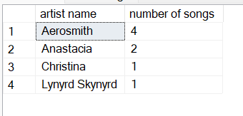

8.for each artist and album how many songs were less than 5 minutes long?

select ar.name 'artist name', al.name 'album name',count(*) 'no, of songs'

from song s

join album al

on s.album_id=al.id

join artist ar on al.artist_id=ar.id

where s.duration<5

group by ar.name,al.name;

Output:

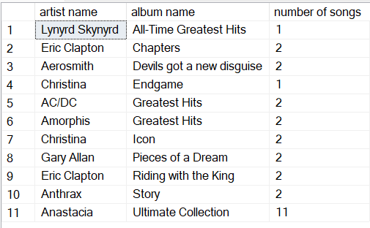

9.In which year or years were the most songs recorded?

select top 1 al.year ,count(*) 'no, of songs'

from song s

join album al

on s.album_id=al.id

join artist ar on al.artist_id=ar.id

group by al.year

order by count(*) desc;

Output:

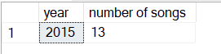

10. list the artist, song and year of the top 5 longest recorded songs

select top 5 ar.name 'artist name',al.name'album name',s.name'song',al.year 'year',s.duration

from song s

join album al

on s.album_id=al.id

join artist ar on al.artist_id=ar.id

order by s.duration desc;

Output:

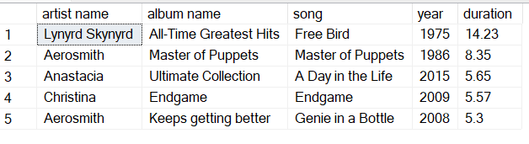

11.Number of albums recorded for each year

select year,count(name)'no, of album'

from album

group by year

order by year ;

Output:

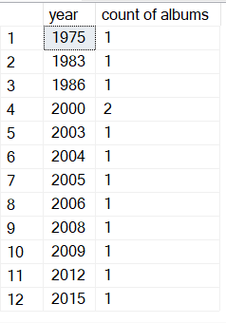

12. What is the max number of recorded albums across all the years?

-- Hint: using the above sql as a temp table

select top 1 year,count(name)'maximum no. of album'

from album

group by year

order by count(name) desc ;

Output:

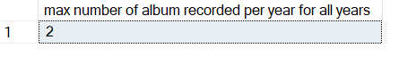

13. In which year (or years) were the most (max) number of albums recorded, and how many were recorded?

-- Hint: using the above sql as a sub-select

select top 1 year,count(name)'maximum no. of album'

from album

group by year

order by count(name) desc ;

Output:

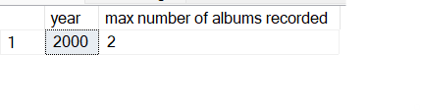

14. total duration of all songs recorded by each artist in descending order

select ar.name 'artist name',round(sum(s.duration),2)'total duration of songs'

from song s

join album al

on s.album_id=al.id

join artist ar on al.artist_id=ar.id

group by ar.name

order by sum(s.duration) desc;

Output:

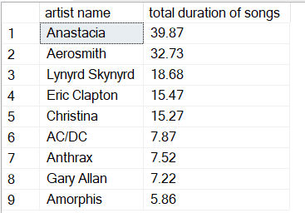

15.for which artist and album are there no songs less than 5 minutes long?

select ar.name'artist name',al.name'album name'

from artist ar

left join album al

on ar.id=al.artist_id

left join song s on s.album_id=al.id and s.duration<5

where s.name is null;

Output:

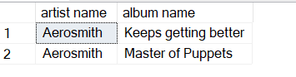

16. Display a table of all artists, albums, songs and song duration -- all ordered in ascending order by artist, album and song

select ar.name'artist name',al.name'album name',s.name'song name',s.duration

from song s

join album al

on s.album_id=al.id

join artist ar on al.artist_id=ar.id

order by ar.name,al.name,s.name asc;

Output:

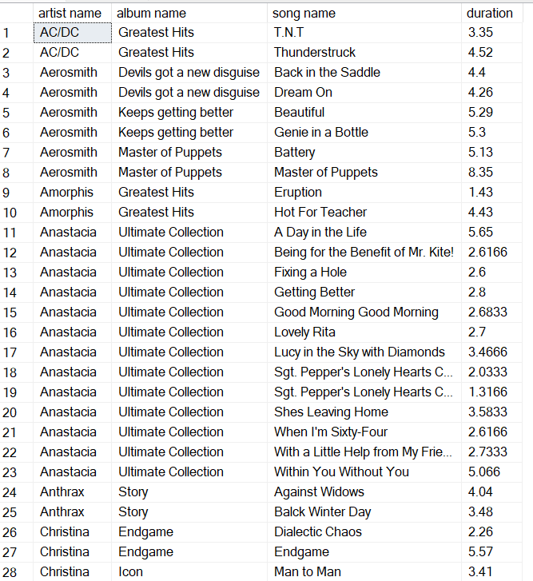

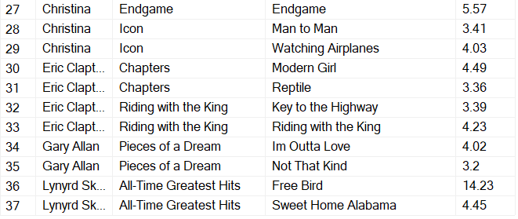

18. Total album length for all songs on the Greatest hits album - in minutes and seconds

select al.name'Album name',

case

when round((sum(s.duration)-cast(sum(s.duration)as int))

,2)>0.60 then cast(sum(s.duration)as int)+1

else cast(sum(s.duration)as int)

end as 'minutes',

case when round((sum (s.duration)-cast(sum(s.duration)as int)),2)>0.60

then (round((sum(s.duration)-cast(sum(s.duration)as int)),2)-0.60)*100

end as 'seconds'

from album al join song s on s.album_id=al.id where al.name like

'Greatest%' group by al.name;

Output:



19. Which artists did not release an album during the decades of the 1980's and the 1990's?

select distinct ar.name 'artist name'

from artist ar

left join album al

on al.artist_id=ar.id and year>= 1980 and year<=1990

where year is null

order by ar.name;

Output:

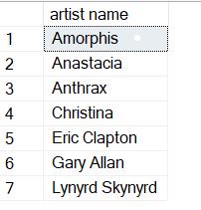

20. Which artists did release an album during the decades of the 1980's and the 1990's?

select distinct ar.name 'artist name'

from artist ar

left join album al

on al.artist_id=ar.id and year>= 1980 and year<=1990

where year is not null

order by ar.name;

Output:

